Information for the General Public

Mpox
(MONKEYPOX VIRUS)
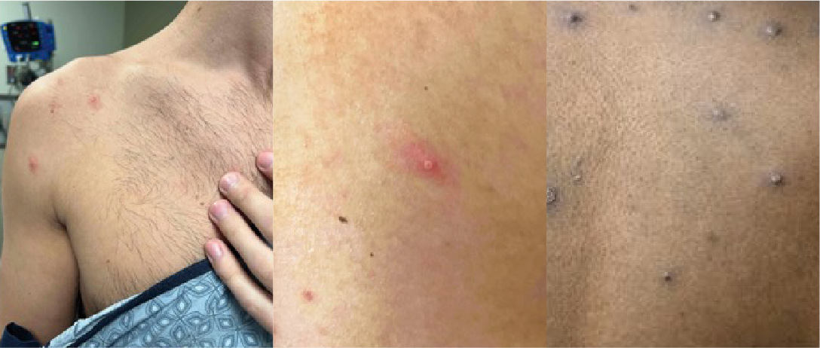

What is Mpox?
Mpox—sometimes called monkeypox—is a rare illness caused by a virus in the same family as the smallpox virus. It can appear as a rash, pimples, or blisters that may be painful or itchy. Despite the similarities, Mpox is not related to chickenpox.
Currently, there are safe and effective vaccines to prevent the onset of Mpox in those who have been or are likely to be exposed to the virus. Talk to your provider about receiving a vaccine if you believe you have been exposed.¹

How is Mpox spread?
Mpox can be spread through…
- Close, physical, often skin-to-skin contact. This can include direct contact with a person’s rash, scabs, body fluids, or objects and surfaces that they used (clothing, bedding, towels).
- Sexual contact, including oral, anal, and vaginal sex, hugging, kissing, sexual gear, and prolonged face-to-face contact.
- A pregnant person to their fetus.
- Consuming meat from an infected animal or being bitten or scratched by an infected animal.²
A person with Mpox can spread it to others from the time symptoms begin until the rash has fully healed. The illness typically lasts from two to four weeks.²
Scientists are still researching if the virus can be spread when a person has no symptoms, if Mpox is spread through respiratory fluids, and if it can spread through semen, vaginal fluids, urine, or feces.²

What are the symptoms?
Mpox typically presents as a rash that can be located on the hands, feet, chest, face, mouth, or even on or near a person’s genitals or anus. The rash can look like pimples or blisters, may be painful or itchy, and will go through several stages of appearance— such as developing scabs—before healing.³
Other symptoms include the following³:
- Fever
- Chills
- Swollen lymph nodes
- Exhaustion
- Muscle aches and backache
- Headache
- Respiratory symptoms
- Sore throat
- Nasal congestion
- Cough
You may experience all or only a few symptoms.
Some people only experience a rash with no other symptoms.
Symptoms usually start within three weeks of exposure to the virus. People who initially have flu-like symptoms typically develop the rash one to four days later.
Mpox can spread from the time symptoms start until the rash has healed, all scabs have fallen off, and a fresh layer of skin has formed. The illness typically lasts 14–28 days.³

How can I protect myself, my family, and my community—especially if I am not vaccinated?
Take these steps to avoid Mpox infection⁴:
Avoid close, skin-to-skin contact with people who have a rash that resembles Mpox
Avoid contact with objects and materials that a person with Mpox has used
Wash your hands often with soap and water for at least 20 seconds—especially before eating or touching your face, and after using the bathroom
- If you live in or are travelling to Central and West African countries, avoid contact with animals such as rodents or primates that can spread Mpox. Avoid sick or dead animals as well as their bedding or other materials they have touched.⁴
Vaccination is recommended for people who have been exposed to Mpox or are more likely to get Mpox. People more likely to get Mpox include⁵
- People who have been exposed to someone with Mpox.
- People whose sexual partners have been diagnosed with Mpox in the past two weeks.
- People who have had multiple sexual partners in the past two weeks in an area with known Mpox outbreaks.
- People whose jobs may expose them to viruses in the Mpox family, such as…
- Laboratory workers who perform testing for viruses in the Mpox family.
- Laboratory workers who handle cultures or animals with viruses in the Mpox family.
- Some designated healthcare or public health workers.

What should I do if I think I have Mpox?
If you are concerned you have symptoms of Mpox, or you have questions regarding this disease, contact your local or state health department. Unless you need immediate medical care, stay home if you are experiencing symptoms.³
- Avoid close contact, sex, or intimacy until you have met with a healthcare provider or visited a public health clinic.
- Call ahead before visiting a healthcare provider and wear a mask at your visit.
- Stay in touch with your healthcare provider. Follow their advice on getting tested for the virus.
- Separate yourself from other people and animals in your home.
- Wear a cloth or medical face mask if you need to be around other people or animals in your home.
- Wash your hands often for at least 20 seconds.
- Avoid sharing personal household items.
- Clean and disinfect all “high-touch” surfaces every day, such as phones, tablets, remote controls, doorknobs, toilets, etc.⁶

List of local resources
Provide a list of resources local to your area as your local/county or state health department will have the most up to date information. See examples below.
King County Public Health's Access and Outreach program, 1–800–756–5437
[INSERT LOCAL/COUNTY/STATE HEALTH DEPARTMENT HERE]

References
- About Mpox. CDC. Updated July 22, 2022. Accessed August 5, 2022. www.cdc.gov/poxvirus/monkeypox/about.html
- How it spreads. CDC. Updated July 29, 2022. Accessed August 5, 2022. www.cdc.gov/poxvirus/monkeypox/transmission.html
- Signs and symptoms. CDC. Updated August 5, 2022. Accessed August 8, 2022. www.cdc.gov/poxvirus/monkeypox/symptoms.html
- How to protect yourself. CDC. Updated July 29, 2022. Accessed August 5, 2022. www.cdc.gov/poxvirus/monkeypox/prevention/protect-yourself.html
- Vaccines. CDC. Updated August 5, 2022. Accessed August 5, 2022. www.cdc.gov/poxvirus/monkeypox/vaccines.html
- Isolation and infection control at home. CDC Updated August 11, 2022. Accessed August 15, 2022. www.cdc.gov/poxvirus/monkeypox/clinicians/infection-control-home.html

