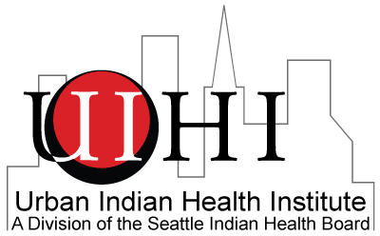
Partnership for Chemical Dependency Treatment Programming: Funding Opportunity for Urban Indian Health Organizations

Background and Purpose: The Seattle Indian Health Board’s (SIHB) Urban Indian Health Institute (UIHI) is pleased to announce an opportunity for Urban Indian Health Organizations (UIHO) to participate in a structured planning process. Supported by a cooperative agreement through the Office of Minority Health (OMH), the partnership is intended to help UIHO increase communication between peers and strengthen chemical dependency treatment programming. Strategic partnerships offer opportunities to share innovative approaches to addressing treatment in a diverse team-driven environment, leverage available and potential resources to support programming and create sustainable peer-to-peer networks aiding UIHOs with program evolution. Selected UIHOs will receive up to $5,500 for participation in partnership activities.

Who Can Apply: Title V UIHOs who have not yet participated in a UIHI facilitated partnership are eligible to apply for the Treatment Programming Award. Two sites will be awarded and paired in this partnership.

UIHO Role: Each UIHO PCDTP team will be contracted with the UIHI to participate in the following activities:

- Identify three staff members, ideally an administrator, service provider and service support professional that will participate in all partnership activities listed below.
- Introductory teleconference with UIHI and peer UIHO.
- Readiness assessment webinar, which will lead UIHO PCDTP teams through dimensions of organizational readiness to implement program change or expansion.
- In-person strategic planning workshop that will use the information from the readiness assessment webinar to develop specific steps towards strengthening programming.
- One of the selected UIHOs will serve as host site and provide meeting space for the in-person strategic planning workshop.
- Opportunities to share and learn from your peers in urban Indian health.

UIHI Role: UIHI technical assistance for the visioning will include:

- Coordination and facilitation of teleconference.
- Facilitation of a webinar on assessing organizational readiness for implementing program change.
- Facilitation of a strategic planning workshop.
- Individual technical assistance on readiness assessment and strategic planning.
- Payment of travel and lodging expenses as well as per diem for in-person workshop when applicable.
- Up to $5,500 through a deliverables based contract to each participating UIHO to support staff to engage in the partnership process.

Please note that the teleconference and in-person workshop will take place in Spring 2014.

To access the Treatment Partnership Award Application, please visit:
http://www.uihi.org/wp-content/uploads/2013/10/SIHB.UIHI_.PCDTP_.application.docx

For more information, please attend the PCDTP webinar on November 14th, 2013 at
10 a.m. PST.

How to Apply
Complete the application and submit by email or fax by
December 6th to:
Urban Indian Health Institute, Seattle Indian Health Board with the subject heading PCDTP Application to:
Email: emmas@uihi.org; Fax: 206-812-3044

Questions about the application process should be addressed to Aren Spark, Project Coordinator
Email: arens@uihi.org; Phone: 206-812-3046

